2B PHYSICS TEST

Heating and Cooling 2012

Student
Name: __________________________

44

TIME: 1 Hour

* A data sheet is supplied for student use

NOTE:

1. Calculations must show clear working with answers written in scientific notation stated to three significant figures unless you are answering a question specifically asking you how many significant figures are technically required.

2. Marks will be allocated for clear and logical setting out.

3. To help identify your answer, underline each answer.

4. State assumptions if working on open ended type questions.

5. Note that NOT all questions carry equal number of marks.

- Answer ALL the questions.

Q1. Fill in the blanks by selecting the correct word from the list below. Each word may be used once or not at all. [4 marks]

ultra violet, convection, conductor, radiation, infra red , insulator, emitter

a) Heat transfer from the Sun to the Earth is primarily by the Infra red [1]
portion of the electromagnetic spectrum.
b) The process of heat transfer that allows a hot air balloon to be inflated by a burning gas under the opening is called Convection [1]
c) People who have been exposed to extreme cold (such as those who are rescued from the sea) are often wrapped in thin shiny aluminium foil emergency sheet. What type of heat loss is such a sheet specifically designed to reduce? Radiation [1]
d) The air pockets trapped between the fibres of roof insulation material reduce heat
transfer because air is a poor Conductor [1] of heat.

Q2. On hot summer days at the beach you can sometimes see people relaxing on a
deck chair with a damp cloth over their forehead. Referring to heat energy concepts,
explain how a wet cloth placed on the forehead can help a person stay cool, even if only luke-warm water is used to dampen the cloth. [3 Marks]

DAMP CLOTH

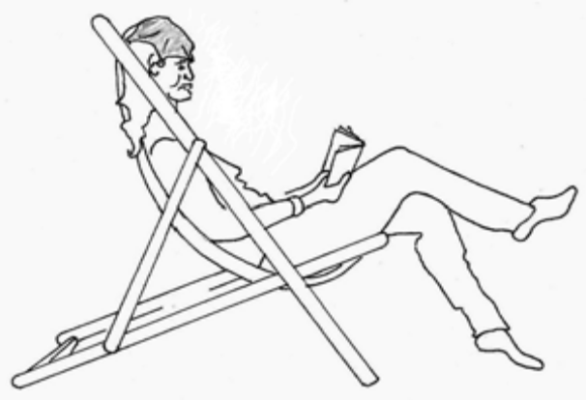

Water evaporates from the wet cloth [1]
The Energy (or heat) is required for the phase change of liquid to gas is removed from the body [1]
This lowers the temperature of the forehead by evaporation which leaves a cooling effect on the skin [1]

Q3. A member of staff at a swimming pool opens a container of a chlorine based liquid cleaning chemical. Within a few seconds his co-worker can smell the chlorine even though she is standing several metres away. This observation is evidence of the particle nature of matter in Kinetic Molecular Theory. Explain why. [2 marks]

Liquid chlorine evaporates at the surface to Cl₂ gas [1].

The air molecules collide with the Cl₂ gas molecules and move then from high to low concentration by diffusion [1]

Q4, a) Explain why a cold glass cracks if it pushed suddenly into boiling hot water.
[2 marks]

Hot water causes the glass’s internal wall to heat up quickly [1].

The glass molecules are unable to expand or transfer to heat at a fast enough rate to the outside wall, hence the glass cracks [1]

b) Explain why the metal copper is a better heat conductor than rubber. [2 marks]

Copper atoms have delocalised (or mobile) electrons which rubber does not [1].

These electrons can pass their kinetic energy onto adjacent atoms through collisions [1]

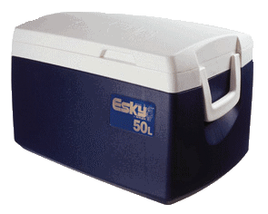

Q5. The picture above shows an Esky, a familiar item used in summer in Australia.

a) A warm bottle of drink is placed in the Esky that contains plenty of ice.

List the physics principles involved in the Esky design and the process whereby the warm drink becomes cooler by being placed in the Esky for a while. [2 marks]

Warm drink cools by absorbing latent heat of ice melting at 0°C [1]

Foam layer prevents heat transfer by conduction. This prevents heat from entering the esky [1]

b) Explain briefly why the inside of an esky is white, rather than black? [2 marks]

it is white inside to minimise or reduce heat transfer by radiation [1].

White does not absorb or radiate heat energy well [1]

Q6. A kettle contains some water. Calculate the heat energy required to change the temperature of 850 g of water from 25.0 ºC to 100 ºC and then boil half of this mass into steam at 100 ºC. Show working out steps carefully to score full marks. [4 marks]

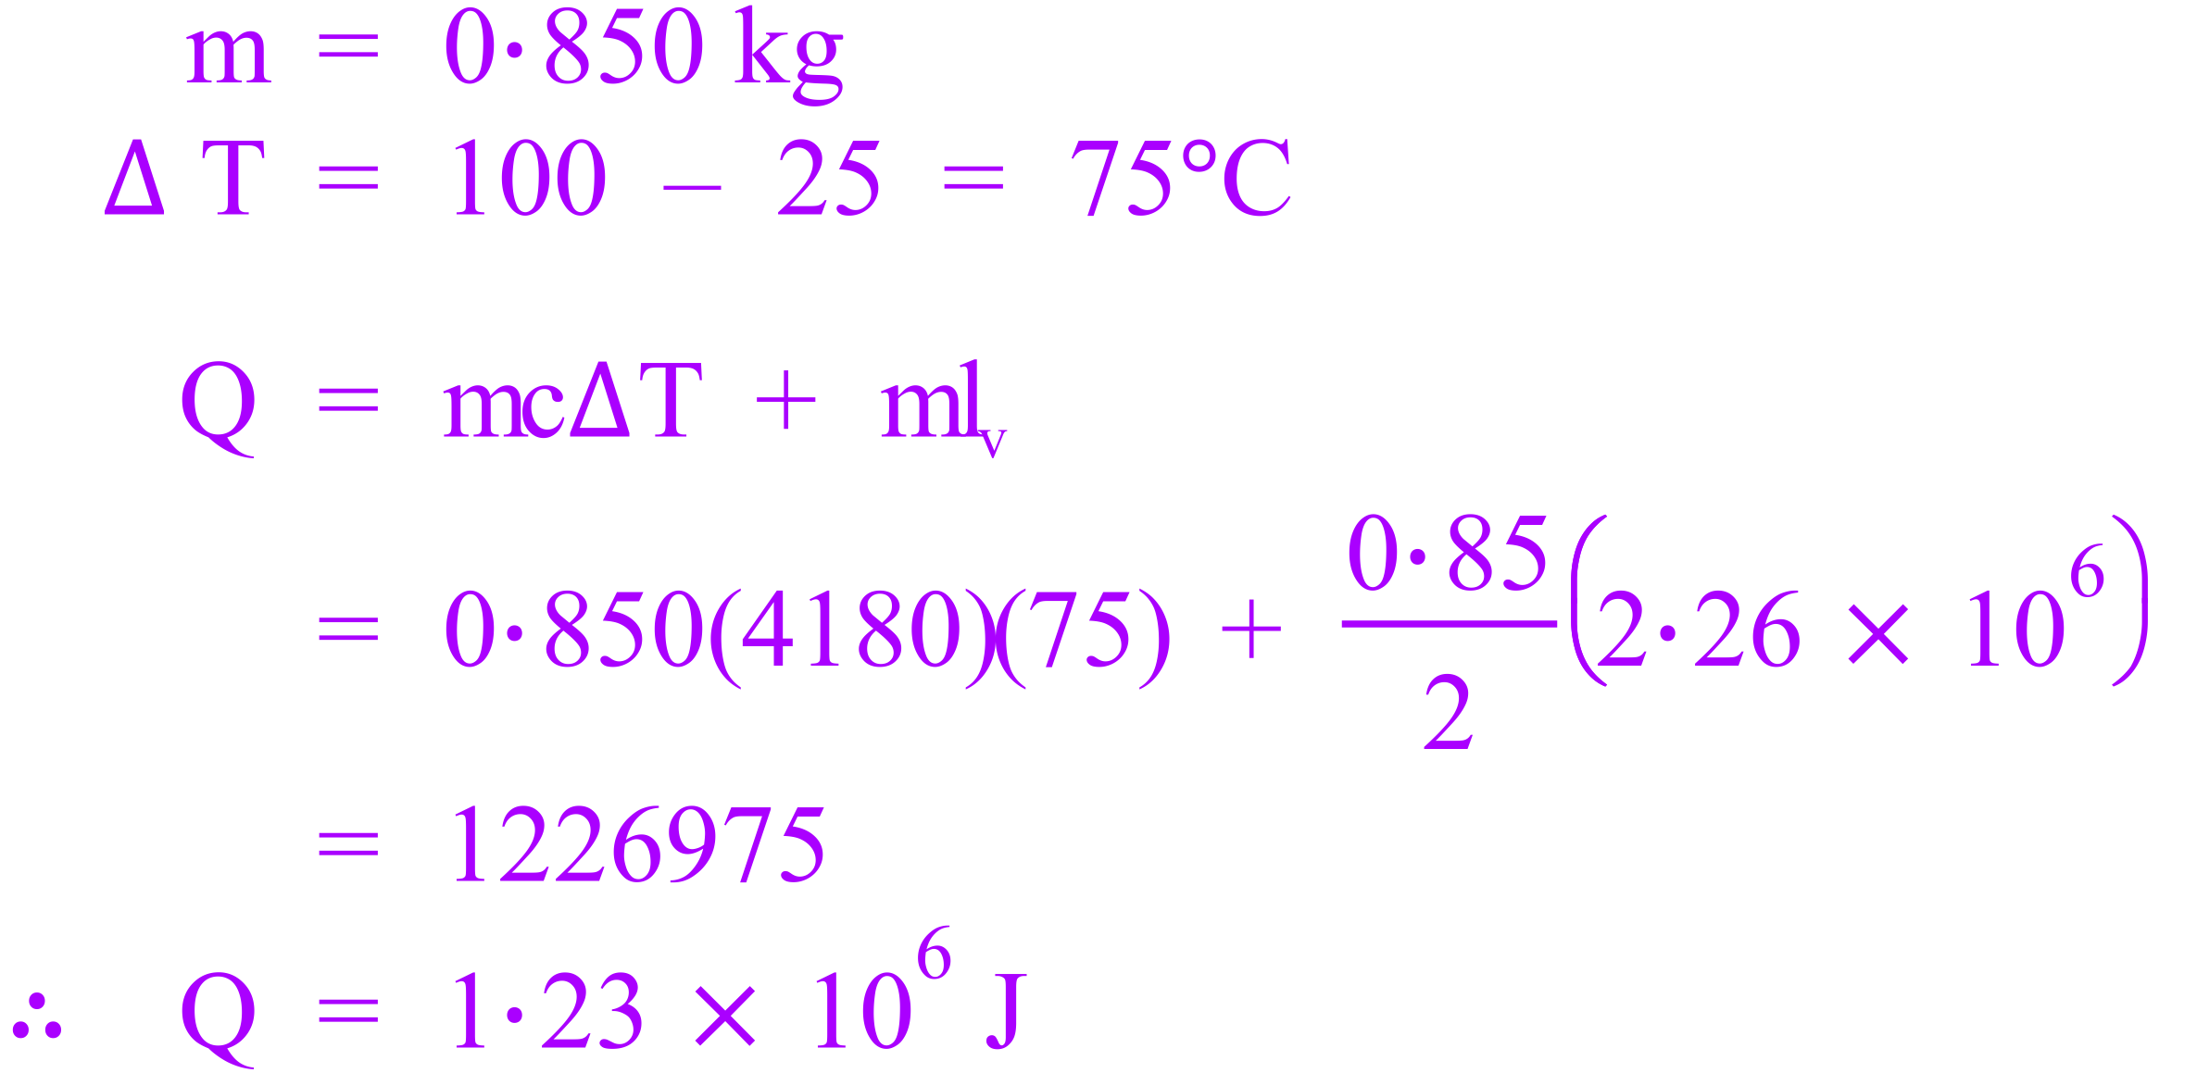

Q7. An 80.0 g block of stainless steel is heated in a furnace and then placed in an insulated polystyrene beaker containing 450 ml of water. The temperature of the water increases from 21.0°C to 42.9°C. Calculate the initial temperature of the stainless steel in the furnace. The specific heat capacity of stainless steel is
445 J kg⁻¹ K⁻¹ and the melting point of stainless steel is approximately 1500°C. [4 marks]

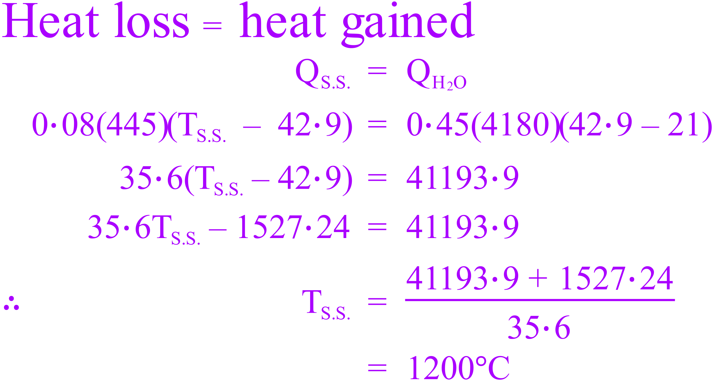

Q8. [10 marks total]

a) Some liquid alcohol of mass 76.0 grams was placed in a glass container and vaporised at 83ºC. The container with the vapour still at 83ºC was placed in a large water tank that was kept at room temperature. The change in temperature of the substance was recorded for 1 minute. 132.4 J of energy was transferred out of the vapour in a 60 second time period. You can consider this rate of heat loss as constant over the 60 seconds. The graph below shows the cooling curve produced. Assume that heat loss to the surroundings was negligible.

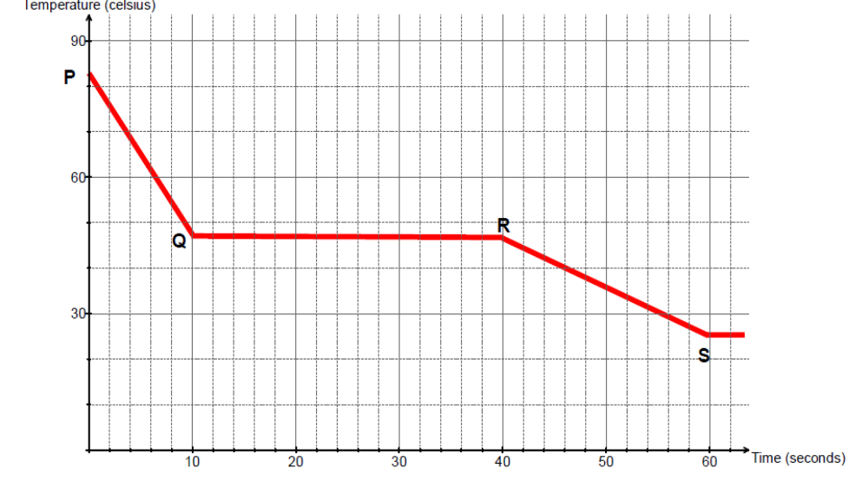
Q8 (i) From the graph, what comparison can you make between the specific heat capacity of the liquid alcohol versus the specific heat capacity of its vapour? No calculation is required.
[2 marks]
C_{vapour} < C_{liquid} [1]
Gradient is steeper, as ΔT decreases vapour releases less energy compared to the liquid [1]

Q8 (ii) What states of matter are present during section Q to R? [1 mark]

Vapour (or gas) and liquid

Q8 (iii) Determine the latent heat of vaporisation (L_{v}) of the alcohol. [3 marks]

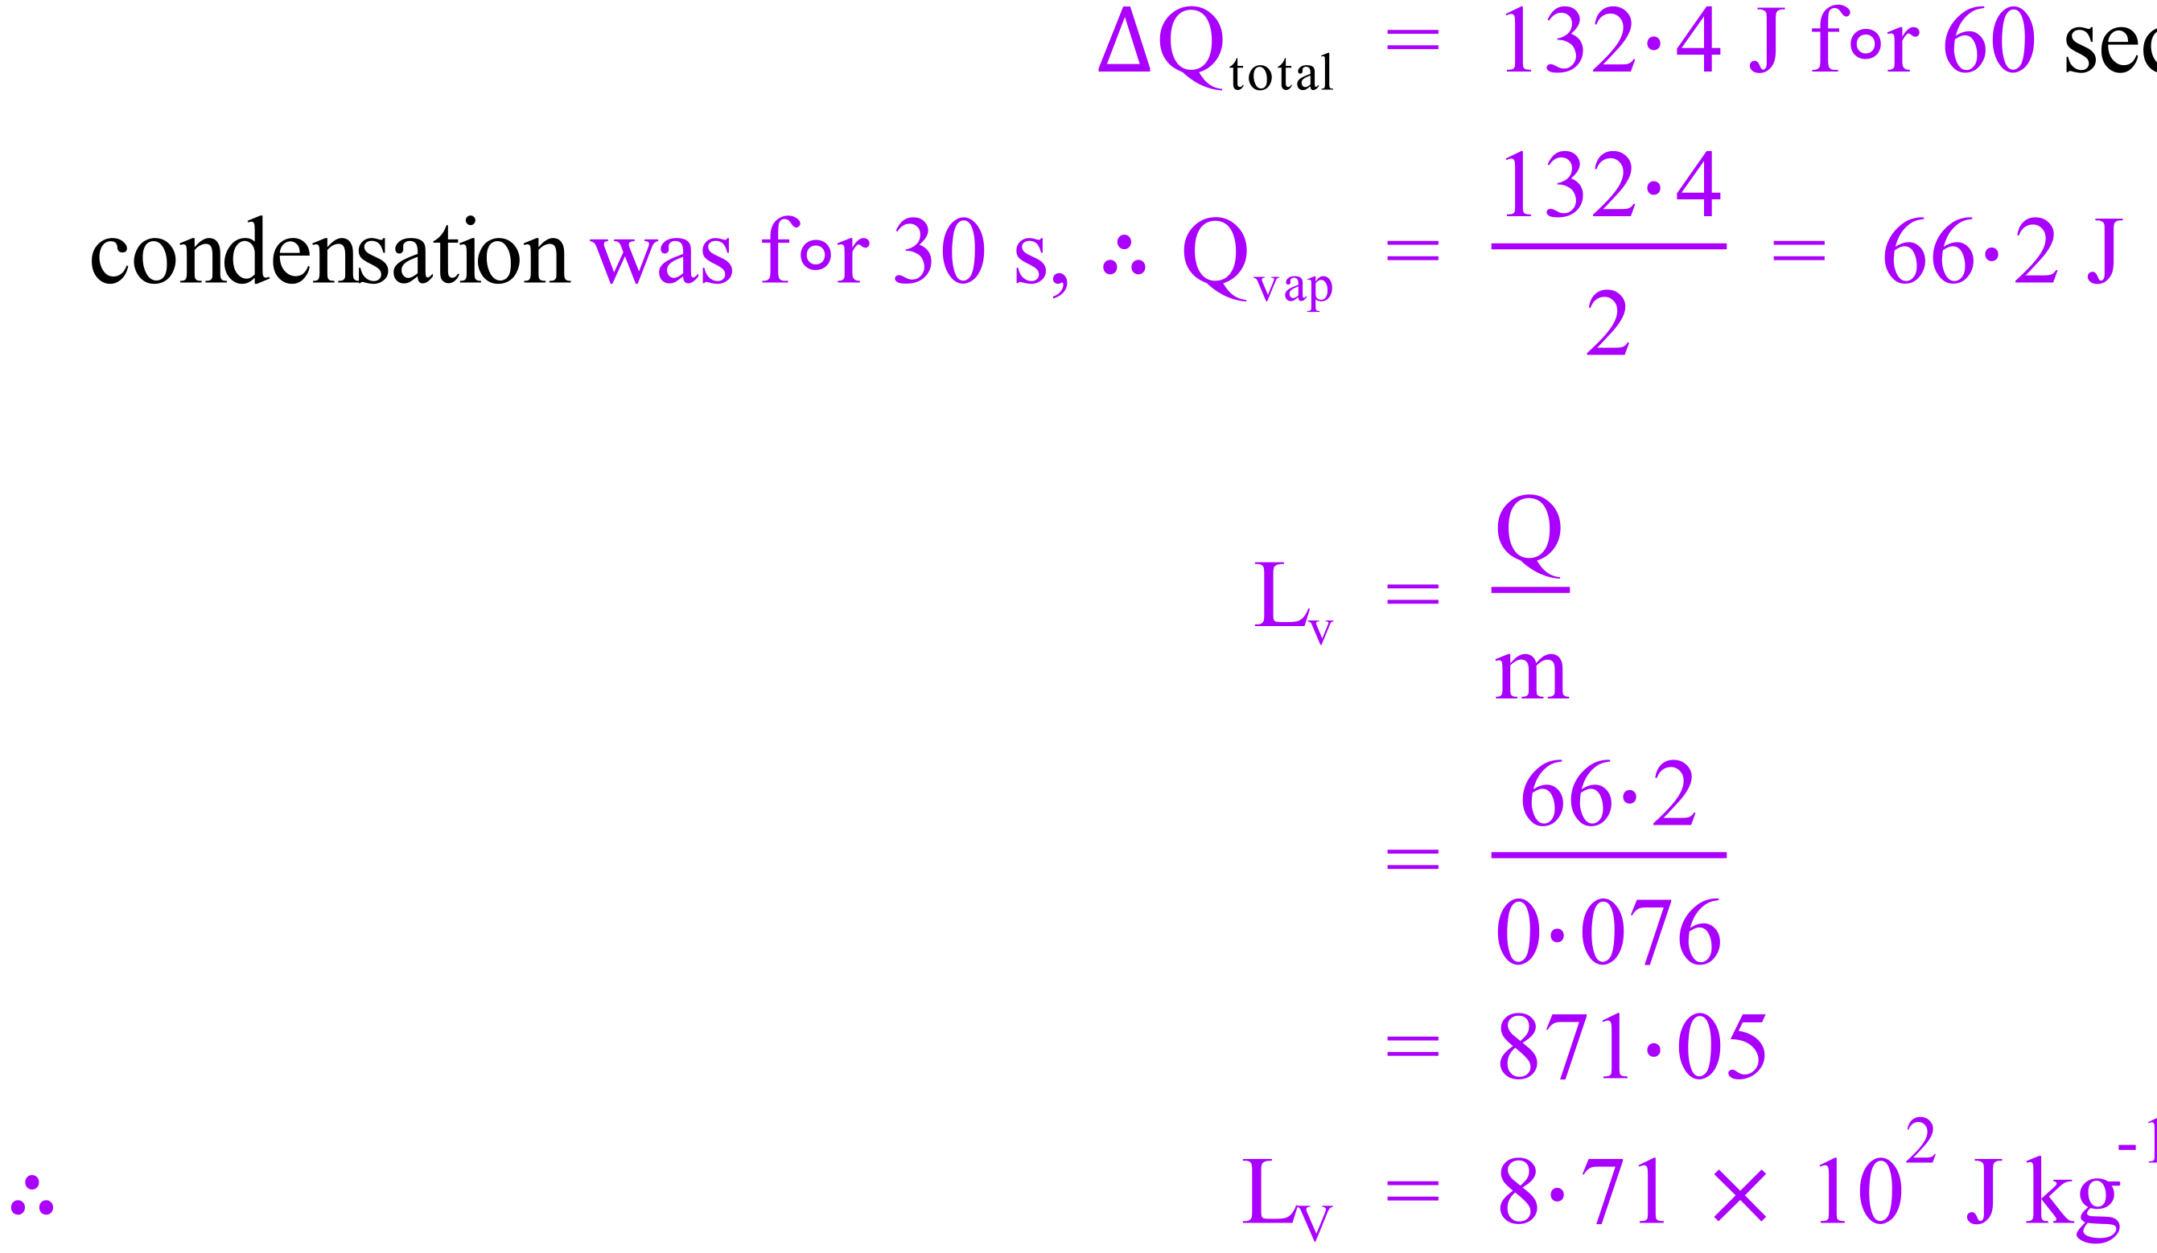

Q8. (iv) In terms of the Kinetic Molecular Theory, explain why the temperature of the substance did not decrease while energy transferred from it to the water between
10.0 and 40.0 seconds. Define temperature as part of your answer. [3 marks]

During condensation at boiling point, vapour changes into liquid, internal energy is released to water [1]

From time 10-40 seconds internal E_{p} changes but internal E_{K} does not [1]

Temperature is related to E_{k} [1]

Q8 (v) Explain what is happening to the alcohol between R and S part of the graph, i.e. between 40 to 60 seconds time interval. [1 mark]

Liquid is cooling, E_{K} decreases as T decreases.

Q9. [1 mark]

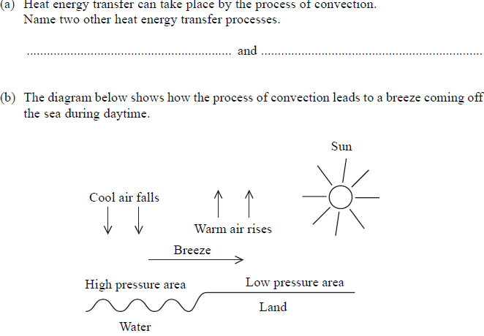

- Conduction & Radiation

.

Q9. continued/……

Q9. During the process the air above the land is heated by the sun and the warm air
rises.

(c) Explain why warm air rises. [2 marks]

As air is warmed is gets less dense [1], cold air is displaced by warm air [1]

(d) Define specific heat capacity [2 marks]

The energy required to change the temperature of 1kg of a substance
by 1°C (or 1 K)

…………………………………………………………………………………………………..

…………………………………………………………………………………………………..

(e) The land is hotter than the sea. Which has the greater specific heat capacity land
or sea? Explain why the land is hotter than Sea. [2 marks]

Sea has greater heat capacity than land [1],
hence the land warms up quicker than sea [1]

…………………………………………………………………………………………………

…………………………………………………………………………………………………

Q10. An immersion heater can supply heater can supply heat at a rate of 58.0 J s⁻¹

(a) How long will it take to heat 125 g of water, originally at 22.0 ◦C, to its boiling point?
[2 marks]

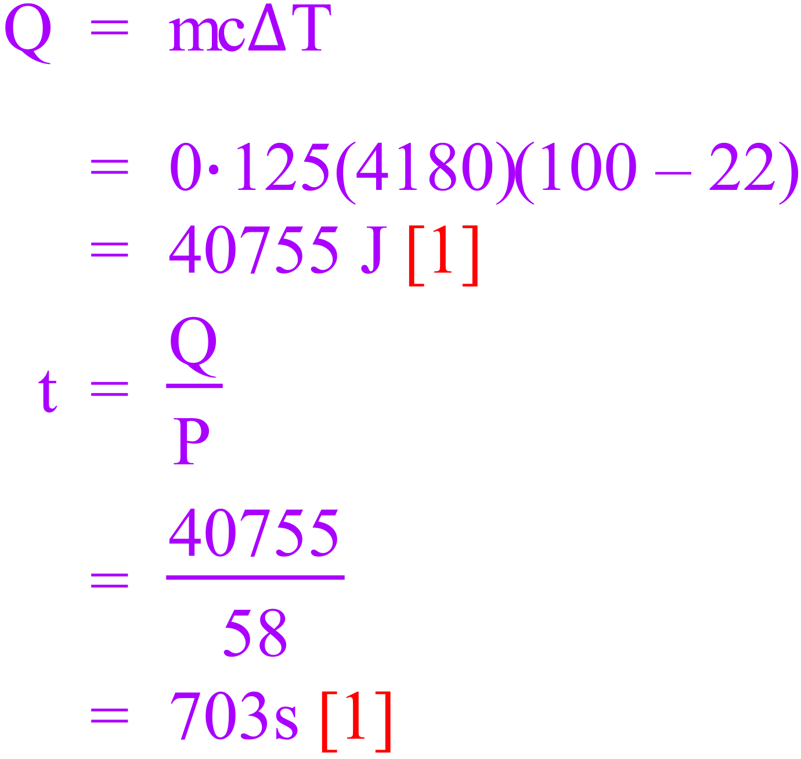

(b) How long will it take to boil away 125 g of water at its boiling point? [1 mark]

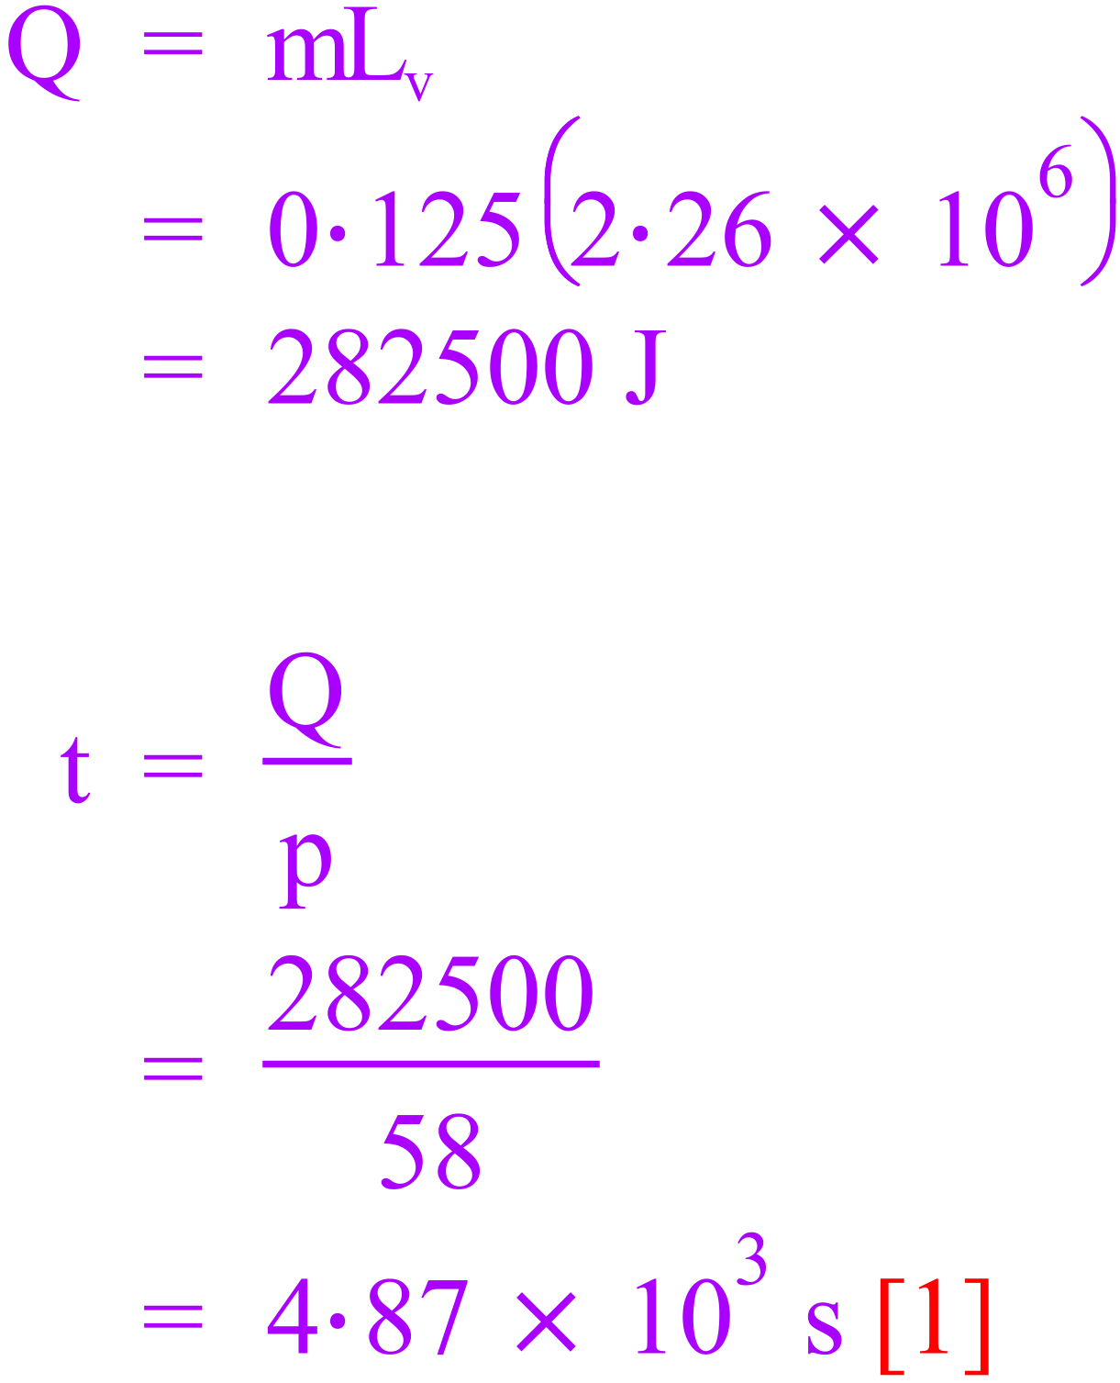

(c) Why are the answers to part (a) and (b) different? Comment briefly using your knowledge of heating and cooling concepts studied. [1 mark]

Greater time to boil due to the greater energy required.

END OF YEAR 11 PHYSICS: HEATING and COOLING TEST 2012

GO BACK AND RE- CHECK YOUR ANSWERS

